Lab: Getting Started with DSXL

Feb 14th, 2018

Author: Sidney Phoon, yfphoon@us.ibm.com
Table of contents
Contents
Overview 1
Required software, access, and files 1
Part 1: Login to Data Science Experience Local 1
Part 2: Create a Jupyter Notebook 5

Overview
In this lab you will learn how to navigate within DSXL and create a new Project.

Required software, access, and files
- To complete this lab, you will need access to a DSX Local cluster.
- You will also need to download and unzip this GitHub repository: https://github.com/SidneyPhoon/DSX_Local_Workshop

Part 1: Login to Data Science Experience Local

- In a Firefox or Chrome browser, go to your assigned DSXL cluster, e.g https://x.x.xxx.xxx/auth/login/login.html

- Click “Sign up” to sign up for an account. Your instructor will approve your account and you can begin the lab

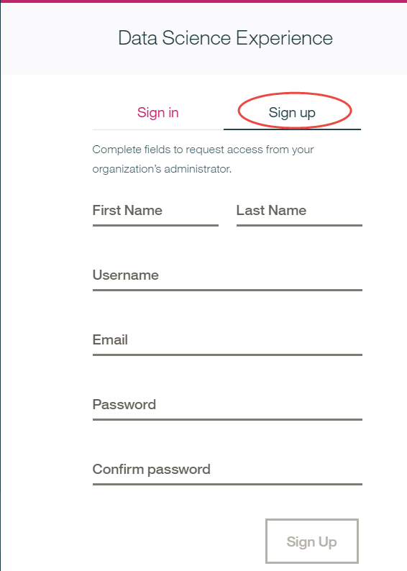

- Sign into DSXL with your username

- In the landing page, explore the Community and View Projects

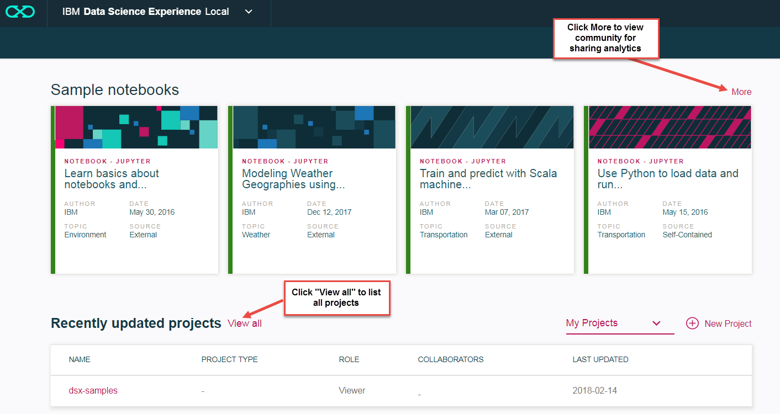

- Click “New Project” to create a “Blank” new project.

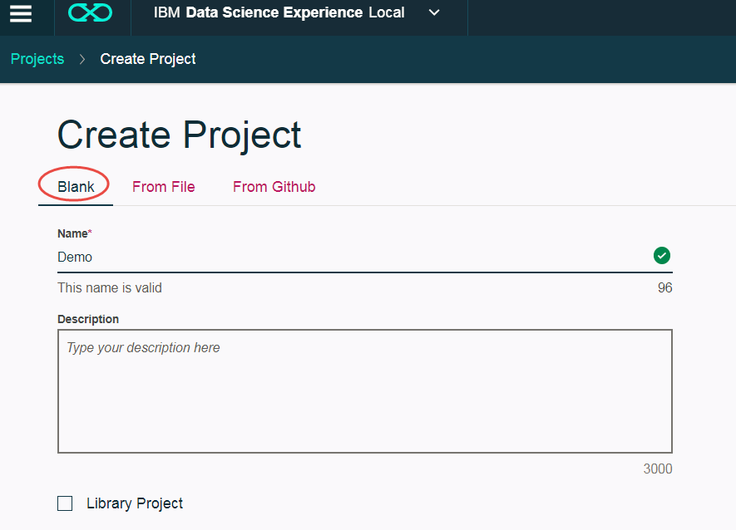

- Click “Assets” to see all the assets in the project
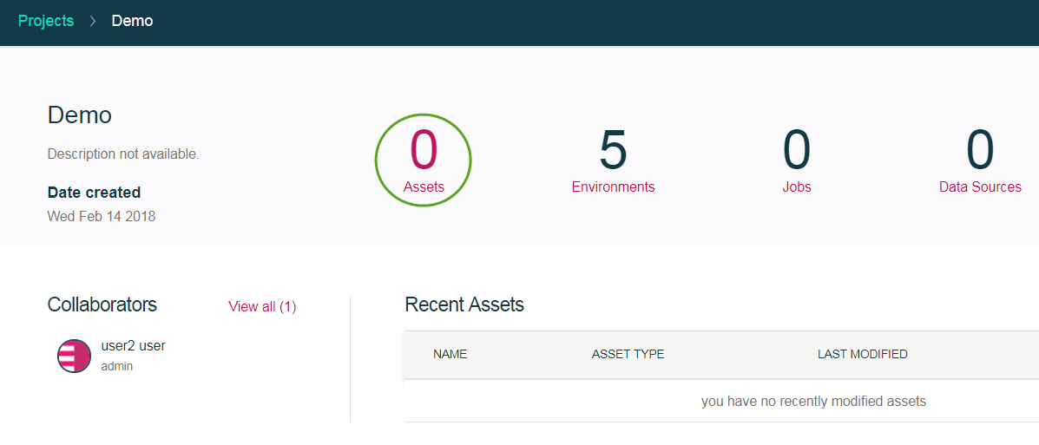

- Click “Data Sets” and then “add data set” to upload a csv file into DSXL
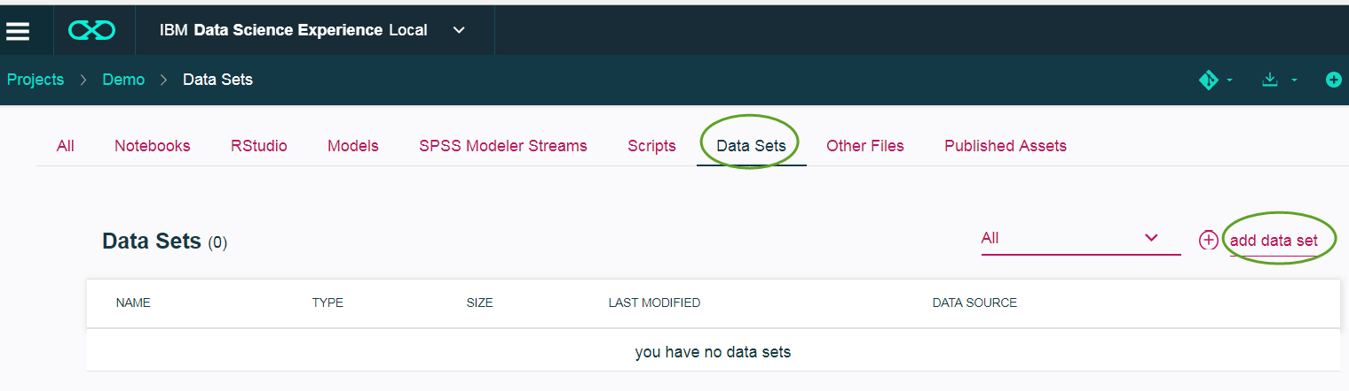

- Load the customer_churn.csv
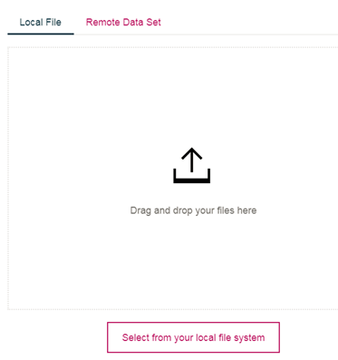
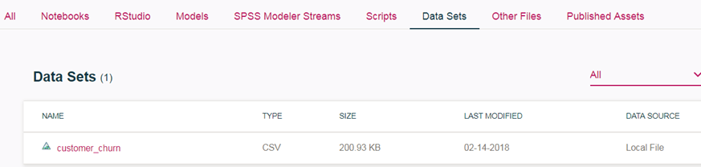

Part 2: Create a Jupyter Notebook

- Within the project you have created in Part 1, click “All”, and “add notebook” to add a blank notebook.
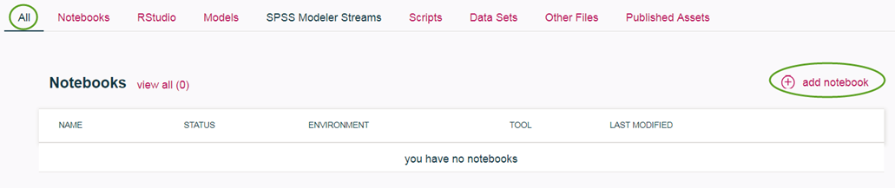

Take the default settings and click “Create”
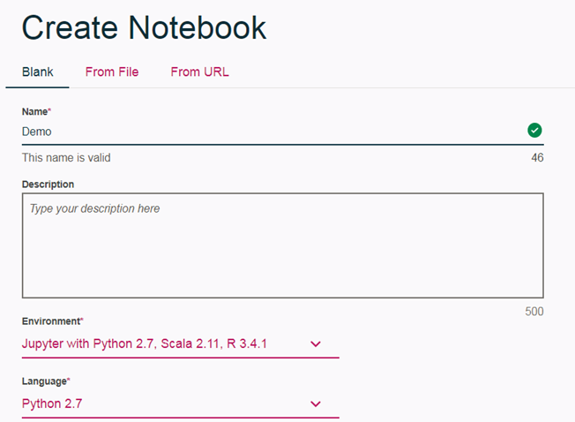

- Define a markdown cell: place the cursor in the first code cell and change the cell type to markdown.
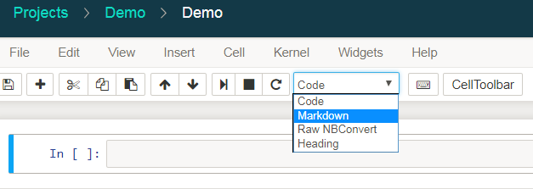

Enter ## Read Data into the markdown cell and click the run icon.
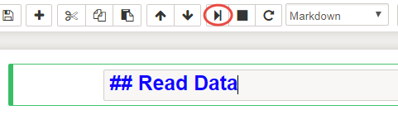
Result:
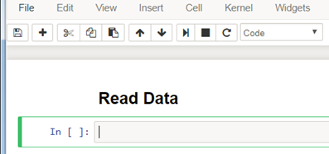

Markdown cheatsheet: https://datascience.ibm.com/docs/content/analyze-data/markd-jupyter.html?context=analytics

- Read data into the notebook: Click the “Find Data” icon, click insert to code to insert the data as a Pandas dataframe. This will generate the code to read the data for further processing in the notebook.
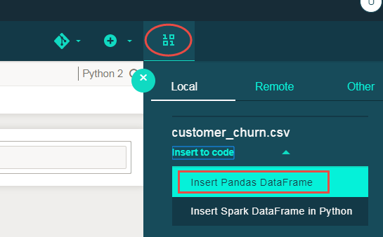

- Run the generated code cell
